CORPORATE USER
Mobile Registration Process

Please note : The steps involved in new registration of mobile numbers as depicted through the following screens, are similar to all the Corporate users namely Regulator, Administrator, maker, Up-loader, Authorizer and Approver.

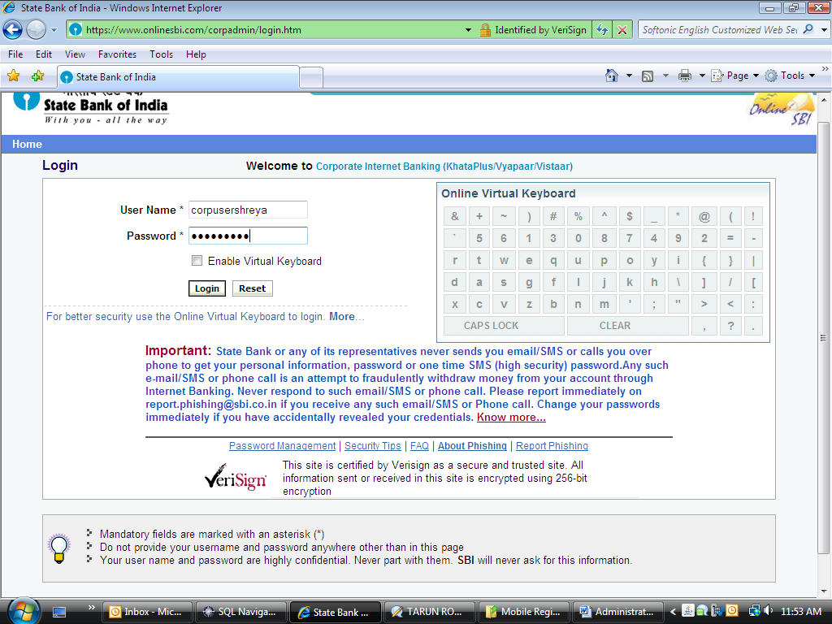
Kindly login with your correct username and password

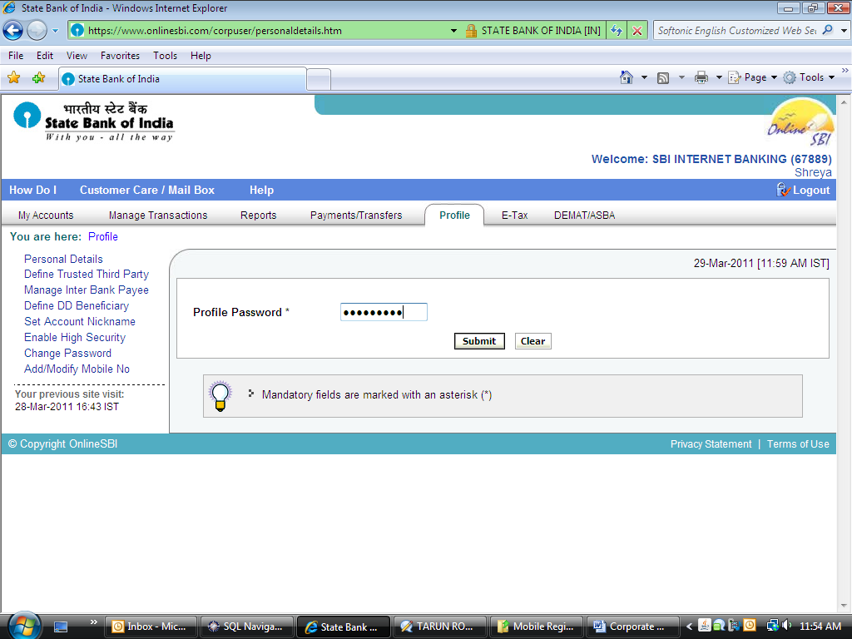
Please click on the ‘Profile tab’
Enter your profile password correctly and click on ‘Submit’ button

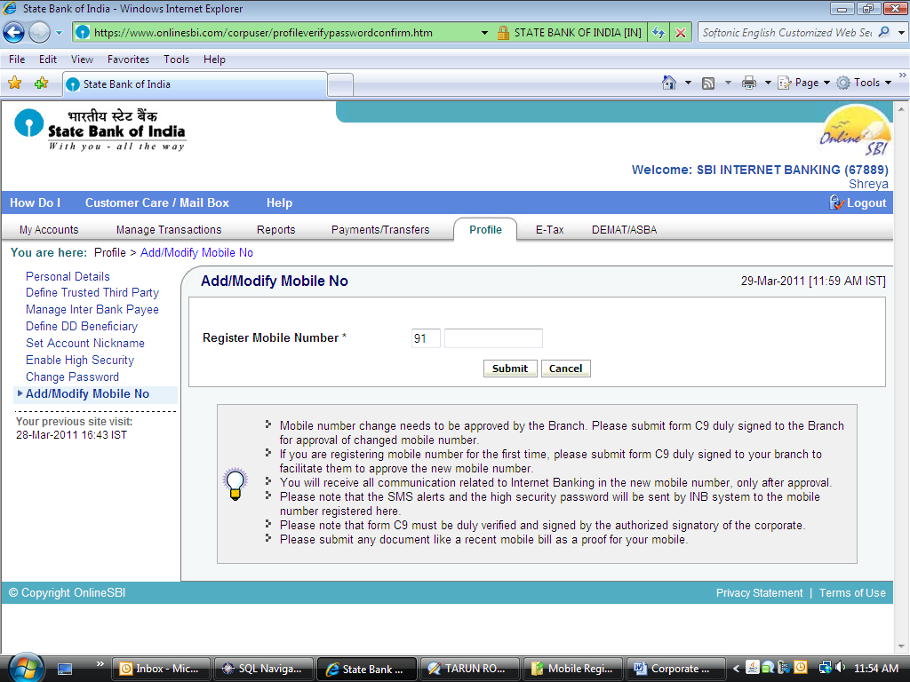
Please read the following instructions carefully.
Please enter your new mobile number here

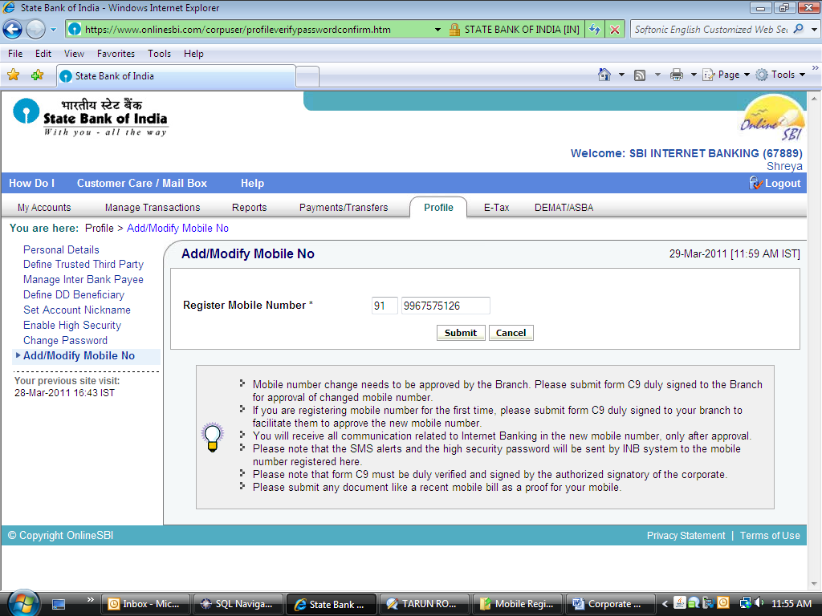
After entering the mobile number, please click on ‘Submit’ button

Please note that the mobile number registered needs to be approved by your branch mandatorily. For this, please print “form C9” in the following screen and submit the same to the branch.

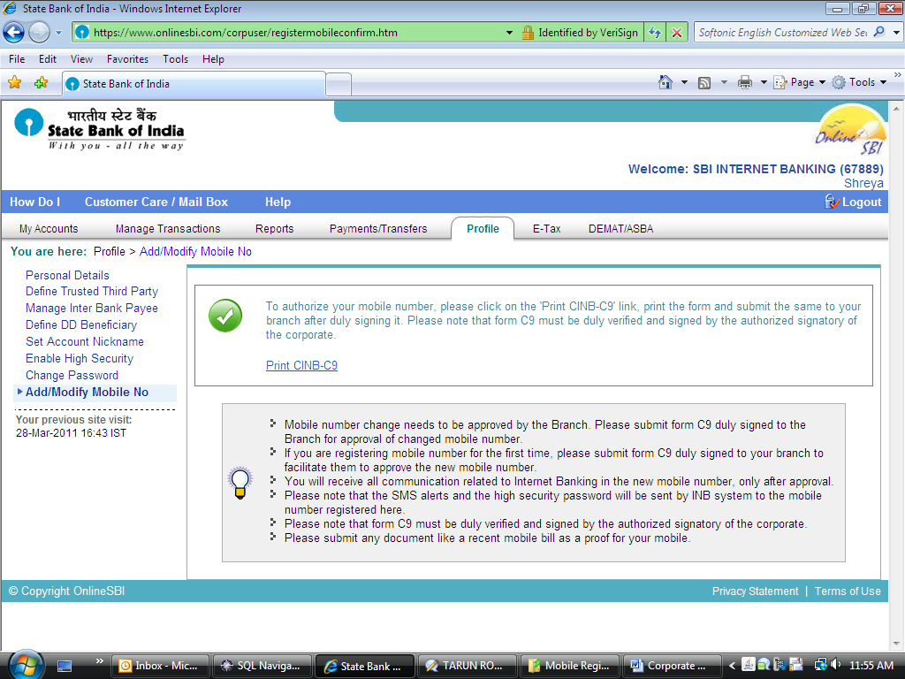
Click here to print form C9.

Pre populated ‘form C9’ opens up.
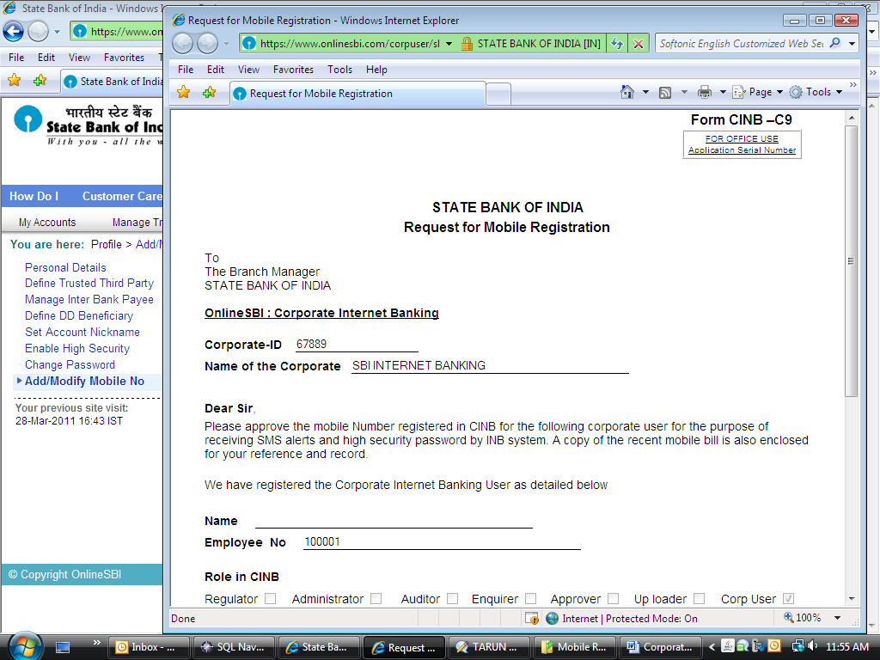
Kindly scroll down

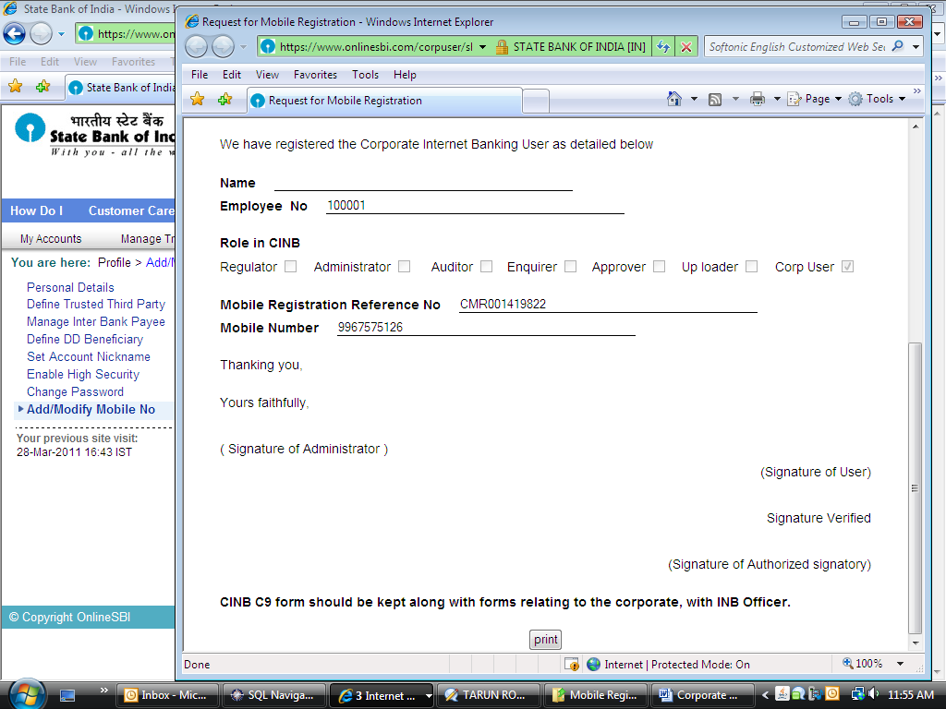
Click on ‘Print’ button and take a print out of ‘form C9’.
Please read the contents of form C9. the Corporate ID, Corporate Name, Employee No, Mobile No and Mobile registration reference number will automatically appear in the form.

Kindly sign here
The C9 form should be duly verified and counter signed by the authorized signatory. Please submit the duly completed ‘form C9 ‘to your Branch for approval of your mobile number

